Supplementary Material
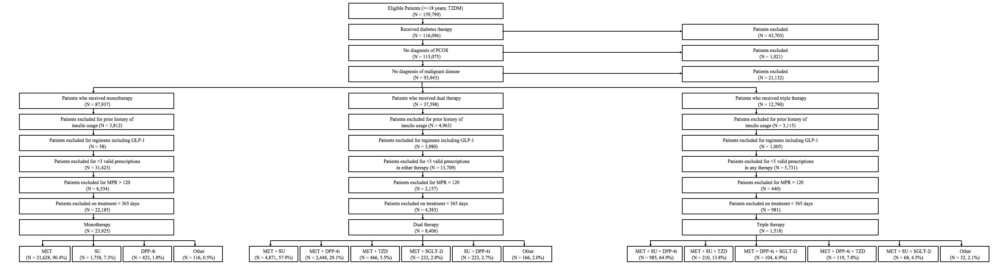
Figure S1. Disposition of patients and OHA therapy cohorts

Table S1. Treatment-related outcomes of interest, stratified by OHA therapy cohort
Regimen | N | One-year HbA1c change (%),  mean (95% CI) | One-year HbA1c change (mmol/mol),  mean (95% CI) | One-year weight change (kg),  mean (95% CI) | Hypoglycemia event rate, n (per 1,000 patient years) | MPR ≥0.80,  % (95% CI)
OHA monotherapy
Overall cohort | 23,925 | -0.8 (-0.9, -0.8) | -8.7 (-9.8, -8.7) | -2.5 (-2.6, -2.3) | 189 (7.9) | 81.6 (81.1, 82.1)
MET | 21,628 | -0.9 (-0.9, -0.8) | -9.8 (-9.8, -8.7) | -2.8 (-3.0, -2.7) | 158 (7.3) | 81.2 (80.7, 81.7)
SU | 1,758 | -0.9 (-1.0, -0.7) | -9.8 (-10.9, -7.7) | 1.3 (0.8, 1.8) | 27 (15.4) | 84.5 (82.8, 86.2)
DPP-4i | 423 | -0.3 (-0.5, -0.2) | -3.3 (-5.5, -2.2) | -1.5 (-2.2, -0.7) | 4 (9.5) | 89.8 (87.0, 92.7)
Other | 116 | -0.5 (-0.8, -0.2) | -5.5 (-8.7, -2.2) | 0.2 (-1.6, 2.0) | 0 | 78.4 (71.0, 85.9)
OHA dual therapy
Overall cohort | 8,406 | -0.9 (-1.0, -0.9) | -9.8 (-10.9, -9.8) | 0.6 (0.4, 0.8) | 152 (18.1) | 80.8 (80.0, 81.7)
MET+SU | 4,871 | -1.0 (-1.1, -1.0) | -10.9 (-12.0, -10.9) | 1.9 (1.6, 2.1) | 108 (22.2) | 79.6 (78.5, 80.7)
MET+DPP-4i | 2,448 | -0.7 (-0.8, -0.6) | -7.7 (-8.7, -6.6) | -1.6 (-1.9, -1.3) | 33 (13.5) | 83.3 (81.8, 84.8)
MET+TZD | 466 | -1.0 (-1.1, -0.8) | -10.9 (-12.0, -8.7) | 2.2 (1.3, 3.0) | 1 (2.1) | 81.3 (77.8, 84.9)
MET+SGLT-2i | 232 | -1.0 (-1.2, -0.8) | -10.9 (-13.1, -8.7) | -5.1 (-5.9, -4.2) | 1 (4.3) | 83.6 (78.9, 88.4)
SU+DPP-4i | 223 | -0.6 (-0.9, -0.3) | -6.6 (-9.8, -3.3) | 0.9 (-0.1, 1.8) | 6 (26.9) | 84.8 (80.0, 89.5)
Other | 166 | -0.7 (-1.0, -0.4) | -7.7 (-10.9, -4.4) | 1.1 (-0.5, 2.8) | 3 (18.1) | 71.1 (64.2, 78.0)
OHA triple therapy
Overall cohort | 1,518 | -1.0 (-1.1, -0.9) | -10.9 (-12.0, -9.8) | 0.5 (0.0, 0.9) | 58 (38.2) | 80.8 (78.8, 82.8)
MET+SU+DPP-4i | 985 | -1.0 (-1.1, -0.9) | -10.9 (-12.0, -9.8) | 0.3 (-0.2, 0.8) | 46 (46.7) | 80.1 (77.6, 82.6)
MET+SU+TZD | 210 | -0.8 (-1.1, -0.5) | -8.7 (-12.0, -5.5) | 2.8 (1.9, 3.7) | 10 (47.7) | 83.3 (78.3, 88.4)
MET+DPP-4i+SGLT-2i | 104 | -1.1 (-1.5, -0.8) | -12.0 (-16.4, -8.7) | -4.0 (-5.4, -2.5) | 0 | 85.6 (16.7, 100.0)
MET+DPP-4i+TZD | 119 | -0.9 (-1.2, -0.6) | -9.8 (-13.1, -6.6) | 2.4 (1.3, 3.5) | 2 (16.8) | 78.2 (70.7, 85.6)
MET+SU+SGLT-2i | 68 | -1.5 (-1.9, -1.0) | -16.4 (-20.8, -10.9) | -2.8 (-5.0, -0.5) | 0 | 77.9 (68.1, 87.8)
Other | 32 | -1.3 (-1.7, -1.0) | -14.2 (-18.6, -10.9) | -1.1 (-3.7, 1.6) | 0 | 87.5 (76.0, 99.0)
CI: confidence interval; DPP-4i: dipeptidyl peptidase-4 inhibitor; HbA1c: glycated hemoglobin A1c; MET: metformin; MPR: medication possession ratio; OHA: oral antihyperglycemic agent; PDC: proportion of days covered; SGLT-2i: sodium-glucose co-transporter-2 inhibitor: SU: sulfonylurea; TZD: thiazolidinedione.

