Table S1: Overview of missing information in EPIC-Potsdam (N=25,392)
Variable | Missing frequency  N (%)
Incident diabetes case | 0
Follow-up time (years) | 0
Age (years) | 0
Prevalent hypertension (yes/no) | 0
Physical activity (h/week) | 0
Former smoker (% < 20 units/d) | 6 (0.02)
Former smoker (% ≥ 20 units/d) | 6 (0.02)
Current smoker (% < 20 units/d) | 6 (0.02)
Current smoker (% ≥ 20 units/d) | 6 (0.02)
Wholegrain intake (bread, muesli) (50g portion/d) | 16 (0.1)
Coffee consumption (150g portion/d) | 16 (0.1)
Intake of red meat (150g portion/d) | 16 (0.1)
Waist circumference (cm) | 36 (0.1)
Waist-to-hip ratio* | 43 (0.2)
Body weight (kg)* | 68 (0.3)
Body height (cm) | 142 (0.6)
Body mass index (kg/m²)* | 187 (0.7)
One parent with diabetes (yes/no) | 3366 (13.3)
Both parents with diabetes (yes/no) | 3366 (13.3)
At least one sibling with diabetes (yes/no) | 3366 (13.3)
GDRS score points* | 3509 (13.8)
Hemoglobin A1C (%) | 22464 (88.5)
* Variables only used in the imputation models
Table S2: Overview of missing information in the GNHIES98 cohort (N=3,717)
Variable | Missing frequency  N (%)
Weighting factor | 0
Clustering | 0
Incident diabetes case | 0
Age (years) | 0
Sex | 0
Prevalent hypertension (yes/no) | 0
Body height (cm) | 11 (0.3)
Waist circumference (cm) | 25 (0.7)
Smoking status (never, former, current) | 41 (1.1)
Wholegrain intake (bread, muesli) (g/d) | 47 (1.3)
Intake of red meat (g/d) | 48 (1.3)
Coffee consumption (g/d) | 52 (1.4)
Sport activity (no sport, <1 h/week, 1–2 h/week, 2–4 h/week, >4 h/week) | 54 (1.5)
Educational level (low, middle, high) | 55 (1.5)
Numbers of cigarettes currently smoked (cig./d) | 70 (1.9)
Numbers of cigarettes previously smoked (cig./d) | 91 (2.4)
Hemoglobin A1C (%) | 135 (3.6)
Mother with diabetes (yes/no) | 366 (9.8)
Father with diabetes (yes/no) | 479 (12.9)

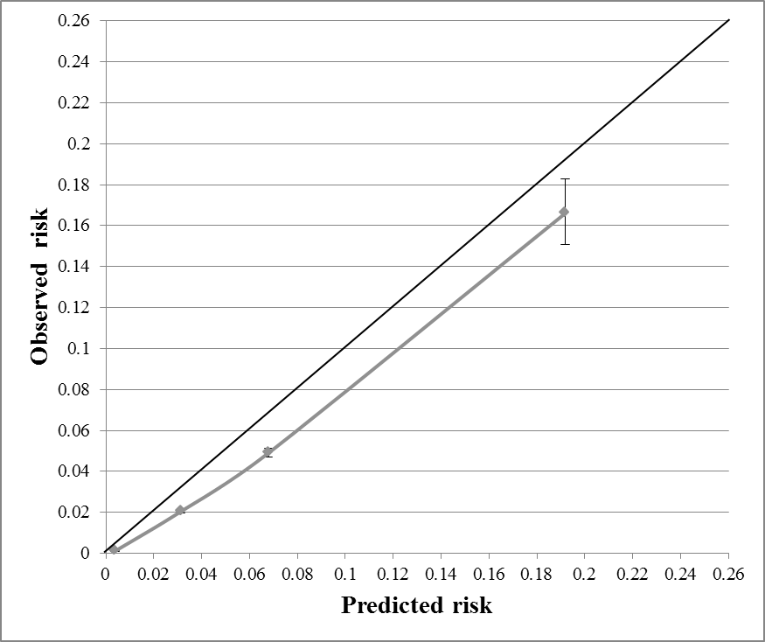
E/O ratio:
1.51 (1.22-1.87)
Supplementary Figure 1: Calibration plot for the clinical GDRS in the GNHIES98 cohort – before recalibration.
Predicted risks were determined using score points, mean score points and the baseline survival as derived from EPIC-Potsdam. Predicted risks were plotted against observed risks in four predefined risk groups (low risk: <2%, still low risk: 2 to <5%, increased risk: 5 to <10%, high or very high risk ≥10% 5-year risk). Expected-to-observed (E/O) ratio was calculated as the number of expected cases (as mean predicted risk multiplied with the overall sample size) divided by the number of observed cases; 95% confidence intervals were determined assuming a Poisson variance.

