Protocol of Gestational Diabetes Management of the Hospital Clínico San Carlos
At the Central Laboratory of the St. Carlos Hospital, universal and centralized screening of GDM is performed between 24-28 gestational weeks (GW), although in most cases it is performed between 24-25 GW. To diagnose GDM a single 2-h 75-g oral glucose tolerance test is performed, applying IADPSG criteria. One inadequate value above the thresholds is enough to diagnose GDM: fasting glucose ≥92mg/dL, 1-hour glucose ≥180mg/dL and 2-hours glucose ≥153mg/dL.

In the same moment women are diagnosed with GDM they are scheduled an appointment at the Diabetes and Pregnancy Unit of the St. Carlos Hospital within one week of the diagnosis. Women diagnosed with GDM receive special healthcare and follow-up at this Unit.

Diabetes and Pregnancy Unit.
Women attend their first visit for evaluation and guidance on GDM treatment.
At this moment, they are given information on what GDM consists of and the impact could have on both the mother and offspring when it is not appropriately treated.
On this first visit they are firstly assessed individually. First, they are evaluated on demographic parameters and family and personal history (Annex 1). They are also evaluated on biochemical (HbA1C, fasting glucose, microalbuminuria, TSH and free T4...) and clinical parameters (Weight, blood pressure) as well as of their lifestyle habits. This is done by using two questionnaires: a semi-quantitative frequency questionnaire, regarding a general healthy dietary pattern (Annex 2a); and the MEDAS questionnaire, specific of a Mediterranean Diet pattern (Annex 2b). They are also instructed on adequate gestational weight gain (GWG).
After individual evaluation, they attend a 1-hour group session in groups ranging from
6-8 women. They are provided with a) indications on self-monitoring blood glucose (SMBG) and b) instruction regarding GDM treatment.

- SMBG.
Regarding SMBG, women are first introduced to the glucose meter and instructed on how to use it. The glucose meter and test strips are given to them free of charge by the Diabetes and Pregnancy Unit. Women are expected to undergo a 6-point doily profile:
Fasting/preprandial and 1h postprandial glycaemia’s at Breakfast, Lunch and Dinner. Results obtained should be written down in a logbook (Annex 3) until their next visit (scheduled one week later).
Glycaemic goals are: fasting or preprandial <90 mg/dL and 1h postprandial <120 mg/dL.
- GDM treatment.
Treatment can be achieved with either diet alone or in combination with insulin therapy. While dietary intervention is the first line therapy, when lifestyle modifications fail to obtain euglycemia, a pharmacologic therapy is required.
- Lifestyle.
Dietary recommendations are based on Mediterranean Diet principles. This includes:
≥two servings/day of vegetables, ≥three servings/day of fruit (avoiding juices), three servings/day of skimmed dairy products, wholegrain cereals, two-three servings/week of legumes, moderate to high consumption of fish; a low consumption of red and processed meat, avoidance of refined grains, processed baked goods, pre-sliced bread, soft drinks and fresh juices, fast foods and precooked meals. Regarding physical activity, they are recommended to walk ≥30 minutes/day (uninterrupted) and climb the stars at least 4 floors/4 times a day (uninterrupted) >5 days per week. This is a recommendation that should be adopted whenever possible. However, it depends on pregnancy status (high/moderate/low risk). Whenever performing physical activity can pose as a threat for the mother and the foetus, it is discouraged to do it.
Women are also insisted on using extra virgin olive oil (EVOO) as their main cooking fat source and nuts as their snacks, both to be included daily in their diet. Whenever possible, EVOO should be used in every meal and nuts should be included at some point in their daily meal-plan (if not as snacks, in salads, with the yoghurt…). A handful/day of nuts and ≥40ml/day of EVOO was recommended.

The nutritional guidance is based on general recommendations rather than specific indications related to daily rations. They receive education on portion control and adequate portions, but aren't given an individualized diet meal plan.

Aside from glycaemic control, women are monitored and instructed on GWG. Body weight goals depend on pregestational BMI: when BMI > 40kg/m², 0kgs WG; >35 kg/m², 3kgs; >30 kg/m², 6kgs; 27 kg/m², 9 kgs; 25 kg/m², 12 kgs; 20 kg/m², 15kgs. If GWG is insufficient, women are told to increase the consumption of EVOO and nuts to easily add extra kcal to their daily caloric intake. If, on the contrary, GWG is excessive, women are recommended to decrease consumption of foods of high caloric density, those rich in saturated fats and control the portions of carbohydrates while increasing those with a low caloric density such as vegetables.

- Insulin therapy.
Insulin therapy is considered when, despite the lifestyle changes, >50% of fasting or preprandial >95 mg/dL and/or 1-h postprandial >140 mg/dL.
If glycaemic control is not achieved, but fasting and preprandial glycaemia’s are 90-94 mg/dL and postprandial glycaemia’s are 120-139 mg/dL, lifestyle adjustments are implemented. Usually to regulate fasting and preprandial glycemia women are encouraged to be more active (walk more or climb the stairs), if possible. To regulate postprandial glycaemia’s, dietary changes are made. One week later, SMBG is re-evaluated. If, regardless of these adjustments, glycaemic control is impaired, insulin therapy is considered as treatment after evaluation ultrasound foetal characteristics. Foetal development (estimated weight) of the 28th gestational week ultrasound is evaluated, and if the foetus is not < 10th percentile, insulin therapy is indicated.

The type of insulin therapy provided depends on the SMBG results. If fasting and preprandial glucose is inadequate, basal insulin is initiated with NPH (when 1 fasting/preprandial profile is impaired), Detemir (when 2 basal/preprandial profiles are impaired) or Glargine (when 3 basal/preprandial profiles are impaired). If postprandial glucose is impaired, bolos insulin is initiated with either Lispro or Aspart. When both are impaired, basal bolus insulin regimen is initiated.
When basal or prandial glycemia is impaired, treatment starts with 2 UI of basal insulin. When postprandial is impaired, 2 UI of bolus insulin before each meal is initiated. One week later, women attend a follow-up visit to evaluate glycaemic control. If it is appropriate, women are instructed to repeat the 6-pomint daily profile every 3 days until 38th gestational week. If it is not, insulin dose is titrated.
Follow-up.
- At the Diabetes and Pregnancy Unit.
Within one week of the first visit, a second appointment is scheduled for assessment of glycaemic control. In this appointment, diabetes-nurses evaluate adherence to the SMBG by assessing results from the memory of glucose meters and logbooks. A good adherence is considered when >80% of the tests are performed correctly, although the expectation is to comply with 100% of the tests. We consider a test to have been performed correctly when there are only ±5 minutes of difference in the timing the postprandial glycaemia’s are taken, when there are no values missing or when there are no discrepancies between the data from the logbook and the meter. A poor adherence is considered when there was <90% of matched values.
If optimal control is achieved after two consecutive visits, women are instructed to repeat the 6-point daily profile every 3 days until 38th gestational week. However, if during this period one profile is above the optimal control, women must return to performing a 6-point daily profile for 3 days and attend the Unit for face-to-face evaluation, or can consult their values over the phone.

On average, scheduled visits in the Unit range between 4-5. The patient is received after diagnosis at 24-26 GW and within one week (at 25-27 GW). After this second visit, they have a scheduled visit every 4 weeks until delivery: 30-32 GW, 34-36 GW and 38-39 GW.
At each scheduled follow-up visit HbA1c levels, microalbuminuria, blood pressure and weight gain are evaluated. Capillary glucose is assessed and episodes of hypoglycaemia, ketosis, insulin dosage and type are registered.
Every time there is a change in the GDM treatment (dietary or insulin dosage adjustments) they are followed-up one week later to monitor the effect.
In addition to the scheduled visits, the patients can attend the Unit without a previous appointment to consult with the diabetes educator issues regarding glycaemic profiles, diet and/or insulin dose.
Some motives of attending non-scheduled visits are:
- Inadequate glucose control.

- Obstetric problems, including hypertension or urinary tract infections (UTIs).

- At the Obstetrics Unit.
In parallel to glycaemic profiles, an important way to monitor glycaemic control is with foetal ultrasound evaluation. Patients attend an ultrasound appointment at 32 GW. If any abnormalities (such as foetal growth retardation, macrosomia, malformations...) are detected, women are scheduled additional ultrasound appointments every 2-4 weeks until delivery.
If in these ultrasound-follow-up visits women are scheduled a C-section, external cephalic version or elective C-section (due to breech delivery, placenta praevia, 2 previous C-sections or mothers interest), they are requested to attend the Diabetes and Pregnancy Unit before the 38 GW.
38 GW
A fasting blood and urine sample is taken.
1. Women are assessed on:
- Gestational weight gain (GWG), blood pressure, UTI (number of events requiring antibiotic treatment), subclinical hypothyroidism and hypothyroxinaemia.
GWG is calculated using pregestational weight as a reference. Excessive GWG is considered so when it exceeds the goal by 3 kg's and insufficient GWG is considered so when its 3 kg’s inferior to the goal.
- Optimal or suboptimal glycaemic targets. Optimal targets for women treated with diet alone are considered as having 4/5 glucose levels on target and HbA1c levels <5.5% (closest possible to 5.0%) and not higher than HbA1c levels of the 24 GW. Optimal targets for women treated with insulin are having HbA1c levels <5.5% and not higher than the levels in 24 GW.
- Women are provided with an appointment for the 3-months-postpartum evaluation.
- They are given the perioperative protocol for glucose control (Annex 4).
When fasting glucose is < 75mg/dL, reduce basal insulin 2-U by 2 that evening, and keep reducing every day.
When 1-hour postprandial glycemia is 70-90mg/dL, reduce bolus insulin the next day 2 by 2-U.

ANNEX 1.

Please, check the response/s that fit your profile

Nationality. Age: This is pregnancy number:

Prior this pregnancy, what was your usual weight? ¿How tall are you?:

In previous pregnancies (if any) check as the case may be:
  - miscarriage
  - gestational diabetes - Hypertension
  - Birth weight: Boy/girl: Gestational weeks: Delivery type:

Before this pregnancy, have you been diagnosed with/treated for:
  - Overweight problems.
  - Cholesterol/triglyceride problems.
  - Blood pressure problems.
  - Glucose or "sugar" problems.

In your family (parents, siblings, children) does someone have/is taking medicine for:
  - Diabetes (high glucose levels)
  - High blood pressure
  - High cholesterol/triglyceride levels.
  - Overweight/obesity.

Please, write down what drugs/supplements you used to take (if any) before the pregnancy. None or list:

Regarding smoking habits, check what defines your current situation: - Never smoked
  - I have smoked until at least 6 months prior to pregnancy. - I have smoked until I knew I was pregnant.
  - I smoke at present (nº cigarettes/day: )

ANNEX 2a.
Please, check the answer that resembles most your physical activity habits and dietary patterns.

Physical activity | (A) | (B) | (C)
Daily strolls | > 1 hour | At least 30 mins | Less than 30 mins
Walking up and down  the stars daily | > 16 floors. | Between 4-16  floors. | Less than 4 floors.  I always take the elevator.
Physical activity at least 30 minutes | ≥ 3 days/week | 2-3 days/week | < 2 days/week

Food (number of times/week you eat it) | A | B | C
Vegetables and salads | > 12 times. | Between 6-12 | < 6 times
Fruits | > 12 times. | Between 6-12 | < 6 times
Nuts | > 3 times | Between 1-3 | Never
Extra virgin olive oil (Not olive pomance) | Daily | ≥3/days | Never
Oily fish (tuna, sardines, salmon...) and iberian cold meat | In more than 3 meals | Between 1-3 meals | <1 meal
Wholegrain bread and cereals (only wholegrain) | > 6/times | Between 3-6 | <3/times
Legumes | >2/times | Between 1-2 | <1/time
Skimmed dairy products (Only skimmed) | > 6/times | Between 3-6 | <3/times
Red meat (cold meat??) | <3/times | Between 3-6 | > 6/times
Sauces mustard, ketchup... (except mayonnaise) | < 2/ times | Between 2-4 | >4/times
Sugary drinks and juices | < 2/ times | Between 2-4 | >4/times
Pastries/biscuits (including wholegrain) | < 2/ times | Between 2-4 | >4/times
Coffee (any type) | >3/day | <3
Water with meals | Exclusively | Mixed with other drinks | Never

ANNEX 2b.
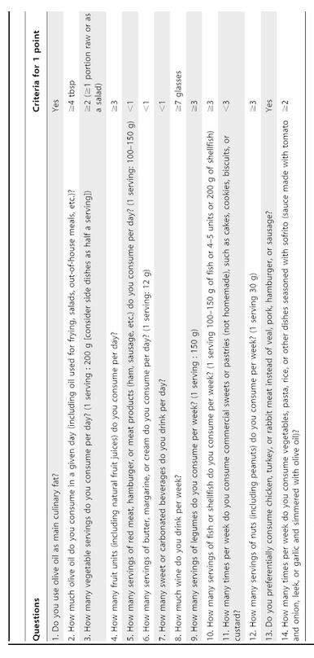

ANNEX 3

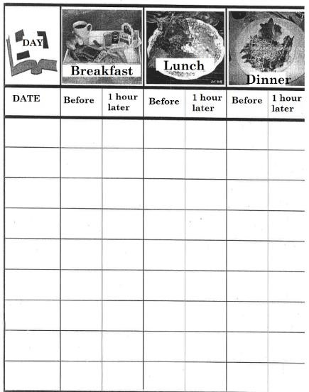

ANNEX 4.

PROTOCOL DURING DELIVERY (VAGINAL AND C-SECTION)

  - Maintain intrapartum maternal glycemia intrapartum between 70 -90 mg/dl, to prevent neonatal hypoglycaemia.
  - Zero/low risk of hypoglycaemia if maternal glycemia is < 90-70 mg/dl.
  - Intrapartum hyperglycaemia is more related to neonatal hypoglycaemia than the peripartum one.
  - In general terms, women do not require insulin intrapartum since contractions during delivery increase insulin sensitivity and reduce insulin needs.

  - When the patient is admitted, the Endocrinology Department should be notified in case any doubts rise.

  - Capillary glycemia should be measured every 2 hours (capillary glycaemic test):

  - If < 90 mg/dl: No need of insulin. If the patient is going to remain with an absolute diet (6-8 hours without ingesting any food), administer serotherapy (in 24 hours):
    - cc of SG 10% + 20 mEq CLK in each SG
+500 cc saline serum 0,9%
*If necessary, the volume can be completed.

  - If ≥ to 90 mg/dl, start the following approach: in Y in 24 hours:
    - cc of SG 10% + 20 mEq CLK in each SG
+500 cc saline serum 0,9%
+insulin pump: 500 cc of saline serum 0,9% with 50 U of crystalline insulin.
Begin at a pace of 10 ml/h.

Measure capillary glucose every 2 hours:
      - If 75-90 (maintain), 90-150 (increase 5 ml/h), 150-200 (increase 10 ml/h) if >200 (increase 20 ml/h) and evaluate every 2 hours until < 200).

      - If 65-75 (decrease 5 ml/h), if <65 discontinue the pump until > 100 and continue with 10 ml/h less than the previous pace.

3) Two hours after delivery or C-section, discontinue insulin infusion and treat the patient as a NON-DIABETIC: basal diet. Perform capillary glucose control before every meal. If fasting glucose exceeds 120 mg/dl, contact de Endocrinology Unit.

