Supplementary Material to:

Plant-derived polyunsaturated fatty acids and markers of glucose metabolism and insulin resistance: a meta-analysis of randomized controlled feeding trials
Anne J. Wanders¹ PhD, Wendy A.M. Blom¹ PhD, Peter L. Zock¹ PhD, Johanna M. Geleijnse² PhD, Ingeborg A. Brouwer³ PhD, Marjan Alssema^{1,4} PhD.
¹ Unilever Research and Development, Vlaardingen, The Netherlands ² Division of Human Nutrition, Wageningen University, Wageningen, The Netherlands ³ Department of Health Sciences, Vrije Universiteit Amsterdam, Amsterdam, The Netherlands ⁴ Department of Epidemiology and Biostatistics, Amsterdam Public Health Research Institute, Amsterdam, the Netherlands

This document contains the following supplemental material:
Supplemental Table 1: Dietary composition of interventions included in the meta-analysis
Supplemental Table 2: Results of studies included in the meta-analysis
Supplemental Table 3: GRADE quality of evidence summary table for comparing a diet high in plant-derived PUFA with SFA or carbohydrates, on measured markers of glucose metabolism and insulin resistance as outcomes
Supplemental Table 4. Results of the analyses of comparing a diet high in plant-derived PUFA with SFA or carbohydrates, on relative changes in fasting glucose, insulin and HOMA-IR, based on fixed effects models
Supplemental Figure 1: Risk of bias assessment
Supplemental Figure 2: Funnel plots for fixed effects of plant-derived PUFA on absolute changes in fasting glucose, insulin and HOMA-IR
Supplemental Figure 3: Dose-response bubble charts# for fixed effects of plant-derived PUFA on absolute changes in fasting glucose, insulin and HOMA-IR
Supplemental Text 1: Literature search in Pubmed

Supplemental Table 1: Dietary composition of interventions included in the meta-analysis
Study | Primary PUFA type | Primary PUFA source | Macronutrient composition | Fatty acid composition | Primary replacement nutrient | Primary replacement nutrient source | Macronutrient composition | Fatty acid composition
 |  |  | CARB/PROT/ Fat (En%) | SFA/MUFA/PUFA (En%) |  |  | CARB/PROT/ Fat (En%) | SFA/MUFA/PUFA (En%)
Bhathena 1989, 1 | omega-6 | common foods | 64/17/19 | 5/7/5 | SFA | common foods | 64/17/19 | 8/6/3
Bhathena 1989, 2 | omega-6 | common foods | 45/16/39 | 11/14/11 | SFA | common foods | 45/16/39 | 18/12/6
Bjermo 2012 | omega-6 | sunfower oil and seeds | 40/17/40 | 10/16/14 | SFA | butter | 40/17/43 | 20/19/4
Brassard 2017, 1 | omega-6 | corn oil | 52/16/32 | 6/13/12 | SFA | cheese | 52/16/32 | 13/13/5
Brassard 2017, 2 | omega-6 | corn oil | 52/16/32 | 6/13/12 | SFA | butter fat | 52/16/32 | 12/12/5
Brassard 2017, 3 | omega-6 | corn oil | 52/16/32 | 6/13/12 | CARB | vegetables, fruits, grains, added sugars | 59/16/25 | 6/13/5
Gillingham 2011 | omega-3 | canola and flaxseed oil | 49/14/37 | 6/16/12 | SFA | olive and sunflower oil, butter, lard | 49/14/37 | 11/16/7
Karupaiah 2016 | omega-6 | soybean oil | 59/12/29 | 8/9/12 | SFA | palm-olein | 59/12/29 | 11/12/7
Keogh 2005, 1 | omega-6 | PUFA margarine, walnuts | 45/17/36 | 9/10/15 | CARB | jam/marmalade, sultanas | 65/16/18 | 7/6/3
Keogh 2005, 2 | omega-6 | PUFA margarine, walnuts | 45/17/36 | 9/10/15 | SFA | butter | 45/16/37 | 19/12/4
Kriketos 2001 | omega-6 | omega-6 vegetable oil | 50/18/32 | 9/23/9 | SFA | butter and shortening | 50/18/32 | 12/29/3
Lichtenstein 2003, 1 | omega-6 | soybean oil | 56/16/29 | 7/8/13 | SFA | butter | 54/17/29 | 17/8/2
Lichtenstein 2003, 2 | omega-6 | soybean and cottonseed oil | 52/17/31 | 9/8/14 | SFA | butter | 54/17/29 | 17/8/2
Rosqvist 2014 | omega-6 | sunflower oil | 43/12/40 | 12/12/13 | SFA | palm oil | 48/12/37 | 16/13/5
Schwab 1997 | omega-6 | sunflower oil | -/-/41 | 10/11/18 | SFA | butter and rapeseed oil | -/-/41 | 21/13/5
St-Onge 2007, 1 | omega-6 * | common foods | 49/16/36 | 9/15/10 | CARB | common foods | 55/15/31 | 9/14/5
St-Onge 2007, 2 | omega-6 * | common foods | 49/16/36 | 9/15/10 | SFA | common foods | 46/16/38 | 11/16/6
Vafeiadou 2015 | omega-6 | safflower oils | 49/16/34 | 8/12/11 | SFA | butter | 48/16/36 | 18/11/4
Vega-Lopez 2006 | omega-6 | soybean oil | 56/16/28 | 7/8/12 | SFA | palm oil | 52/18/30 | 15/11/4
Abbreviations: Carb, carbohydrates; En%, percentage of daily energy; PROT, protein; PUFA, poly-unsaturated fatty acids; SFA, saturated fatty acids.
* The paper does not indicate PUFA type, therefore it is assumed to be omega-6 as this is the primary PUFA type in common foods.

Supplemental Table 2: Results of studies included in the meta-analysis
Study | Glucose |  |  | Insulin |  |  | HOMA-IR
 | Baseline (se) (mmol/l) * | Absolute change (mmol/l) | Relative change (%) | Baseline (se) (pmol/l) * | Absolute change (pmol /l) | Relative change (%) | Baseline (se) * | Absolute change (units) | Relative change (%)
Bhathena 1989, 1 |  |  |  | 74.7 (5.5) | 3.4 | 4.0
Bhathena 1989, 2 |  |  |  | 74.7 (5.5) | 6.0 | 7.9
Bjermo 2012 | 5.4 (0.2) | 0.07 | 1.2 | 70.8 (8.2) | -9.6 | -12.4 | 2.6 (0.4) | -0.27 | -8.1
Brassard 2017, 1 | 5.2 (0.1) | 0.00 | 0.0 | 118 (8.0) | 0.0 | 0.0 | 3.9 (0.3) | -0.03 | -0.8
Brassard 2017, 2 | 5.2 (0.1) | 0.03 | 0.6 | 118 (6.8) | 0.0 | 0.0 | 3.8 (0.2) | 0.04 | 1.1
Brassard 2017, 3 | 5.2 (0.1) | 0.05 | 1.0 | 115 (6.5) | 3.0 | 2.6 | 3.7 (0.2) | 0.17 | 4.7
Gillingham 2011 | 5.0 (0.2) | -0.07 | -1.4
Karupaiah 2016 | 4.8 (0.1) | -0.04 | -0.6
Keogh 2005, 1 |  |  |  | 44.5 (4.1) | -5.0 | -11.2
Keogh 2005, 2 |  |  |  | 45.2 (6.0) | -5.6 | -12.5
Kriketos 2001 | 5.8 (0.2) | 0.41 | 6.1 | 233.1 (28.3) | 18.3 | 5.8
Lichtenstein 2003, 1 | 5.2 (0.1) | -0.11 | -2.1 | 74.4 (7.5) | -7.2 | -9.7 | 2.8 (0.2) | -0.32 | -11.3
Lichtenstein 2003, 2 | 5.2 (0.1) | -0.11 | -2.1 | 74.4 (7.5) | -4.8 | -6.5 | 2.8 (0.2) | -0.23 | -8.3
Rosqvist 2014 | 4.6 (0.1) | 0.12 | 2.6 | 32.3 (3.3) | -0.1 | -2.9 | 1.1 (0.1) | 0.04 | 0.6
Schwab 1997 | 4.1 (0.1) | -0.22 | -5.2 | 51.7 (7.5) | -8.8 | -15.5
St-Onge 2007, 1 | 5.1 (0.1) | 0.08 | 1.6 | 98.4 (7.1) | -2.4 | -2.4 | 3.8 (0.3) | -0.06 | -1.6
St-Onge 2007, 2 | 5.2 (0.1) | -0.03 | -0.5 | 100.2 (8.3) | -4.2 | -4.2 | 4.0 (0.4) | -0.21 | -5.3
Vafeiadou 2015 | 5.1 (0.1) | -0.02 | -0.6 | 30.5 (2.4) | 0.4 | 1.8 | 1.2 (0.1) | 0.00 | 1.3
Vega-Lopez 2006 | 5.0 (0.2) | -0.17 | -3.3 | 63.2 (5.9) | -5.5 | -8.7 | 2.4 (0.2) | -0.31 | -13.1
Abbreviations: HOMA-IR, homeostatic model assessment-insulin resistance; sd, standard deviation.
* For parallel studies, average baseline concentrations were calculated based on the baseline concentrations in the active and control groups. For cross-over studies, the baseline concentrations were used when reported; otherwise the end-of-intervention concentrations of the control periods were used.

Supplemental Table 3: GRADE quality of evidence summary table for comparing a diet high in plant-derived PUFA with SFA or carbohydrates, on measured markers of glucose metabolism and insulin resistance as outcomes
Outcome | no of studies (comparisons) | design | quality assessment for comparison |  |  |  |  |  | no of participants | effect (95%CI) | Level of quality (GRADE)¹ | Importance
 |  |  | risk of bias | inconsistency | indirectness | imprecision | publication bias | other considerations
Fasting glucose | 10 (15) | RCT | no serious risk ² | no serious risk ³ | serious risk ⁴ | no serious risk ⁵ | no serious risk ⁶ | None | 505 | -0.01 (-0.06; 0.03) mmol/l | XXXO (Moderate) ⁷ | critical
Fasting insulin | 11 (17) | RCT | no serious risk ² | no serious risk ³ | serious risk ⁴ | no serious risk ⁵ | no serious risk ⁶ | None | 506 | -2.56 (-4.88; -0.24) pmol/l | XXXO (Moderate) ⁷ | critical
HOMA-IR | 7 (11) | RCT | no serious risk ² | no serious risk ³ | serious risk ⁴ | no serious risk ⁵ | no serious risk ⁶ | None | 390 | -0.12 (-0.23; -0.01) | XXXO (Moderate) ⁷ | important
Abbreviations: GRADE, Grading of Recommendations Assessment, Development, and Evaluation; HOMA-IR, homeostatic model assessment-insulin resistance; PUFA, poly-unsaturated fatty acids; RCT, randomized controlled trial; SFA, saturated fatty acids.
¹ High certainty: we are very confident that the true effect lies close to that of the estimate of the effect. Moderate certainty: We are moderately confident in the effect estimate (the true effect is likely to be close to the estimate of the effect, but there is a possibility that it is substantially different). Low certainty: our confidence in the effect estimate is limited (the true effect may be substantially different from the estimate of the effect. Very low certainty: we have very little confidence in the effect estimate (the true effect is likely to be substantially different from the estimate of effect).
² bias: most information is from studies at low or unclear risk of bias, the plausible bias is unlikely to seriously alter the results.
³ inconsistency: funnel plots and quantified tests (Cochranes Q-test and I2) did not suggest heterogeneity.
⁴ indirectness: in most studies the outcomes were not primary outcomes, thus studies were not designed to assess effects on glucose, insulin and HOMA-ir. Of the included studies, only few show statistically significant effects on glucose, insulin and HOMA-ir.
⁵ imprecision: wide confidence intervals of individual studies, but the confidence intervals between studies overlap. There are a sufficient number of participants and strata to answer the main research questions.
⁶ publication bias: bias assessment did not indicate selective reporting, and funnel plots and quantified tests (Eggers weighted regression test) did not indicate publication bias.
⁷ Downgraded 1 level for serious indirectness.

Supplemental Table 4. Results of the analyses of comparing a diet high in plant-derived PUFA with SFA or carbohydrates, on relative changes in fasting glucose, insulin and HOMA-IR, based on fixed effects models.
 |  | Glucose |  |  | Insulin |  |  | HOMA-IR
Study characteristic | Stratification variable | Comparisons (n) | Change vs control, mmol/L (95% CI) | P-value * | Comparisons (n) | Change vs control, pmol/L (95% CI) | P-value* | Comparisons (n) | Change vs control, units (95% CI) | P-  value *
Overall |  | 15 | -0.05 (-0.75; 0.65) | 0.889 | 17 | -2.8 (-6.0; 0.3) | 0.079 | 11 | -4.4 (-8.5; -0.4) | 0.030
Replacement nutrient | SFA | 13 | -0.38 (-1.17; 0.40) | 0.064 | 14 | -3.0 (-6.7; 0.7) | 0.848 | 9 | -6.0 (-10.5; -1.5) | 0.151
 | Carbohydrates | 2 | 1.26 (-0.29; 2.81) |  | 3 | -2.3 (-8.5; 3.9) |  | 2 | 1.2 (-7.5; 9.9)
Dose-response, continu | Per 5%En | 15 | -1.38 (-3.32; 0.56) | 0.164 | 17 | -8.5 (-14.2; -2.8) | 0.004 | 11 | -7.0 (-15.4; 1.4) | 0.100
PUFA dose | Tertile 1† | 5 | 0.01 (-1.11; 1.14) | 0.081 | 5 | 0.8 (-4.9; 6.6) | 0.009 | 2 | -3.3 (-11.8; 5.2) | 0.035
 | Tertile 2 | 5 | 0.43 (-0.57; 1.44) |  | 6 | -0.4 (-5.2; 4.4) |  | 5 | 1.4 (-5.1; 8.0)
 | Tertile 3 | 5 | -2.08 (-4.03; -0.12) |  | 6 | -11.1 (-17.2; -4.9) |  | 4 | -10.5 (-16.9; -4.2)
PUFA type | omega-6 PUFA | 14 | -0.02 (-0.72; 0.69) |  | 17 |  |  | 11
 | omega-3 PUFA | 1 |  |  | 0 |  |  | 0
Intervention duration | ≤4 wk | 8 | 0.16 (-0.63; 0.96) | 0.278 | 8 | -3.3 (-7.3; 0.6) | 0.663 | 5 | -0.5 (-6.0; 5.0) | 0.039
 | >4 wk | 7 | -0.75 (-2.19; 0.69) |  | 9 | -1.9 (-7.2; 3.4) |  | 6 | -9.0 (-14.9; -3.1)
Design | Crossover | 11 | -0.16 (-0.91; 0.59) | 0.421 | 11 | -4.3 (-7.8; -0.8) | 0.066 | 8 | -4.8 (-8.9; -0.6) | 0.609
 | Parallel | 4 | 0.71 (-1.26; 2.68) |  | 6 | 3.1 (-3.9; 10.1) |  | 3 | -0.9 (-15.1; 13.3)
Industry funding | No | 7 | -0.93 (-2.69; 0.82) | 0.283 | 9 | -4.0 (-9.1; 1.2) | 0.295 | 5 | -9.9 (-16; -3.8) | 0.021
 | Partial/Full | 8 | 0.12 (-0.65; 0.88) |  | 6 | -0.4 (-4.7; 3.9) |  | 6 | -0.4 (-5.7; 5.0)
Control over food intake | Partial | 4 | 0.04 (-1.99; 2.07) | 0.928 | 6 | -9.9 (-16.7; -3.0) | 0.023 | 3 | -0.9 (-15.1; 13.3) | 0.609
 | Full | 11 | -0.06 (-0.81; 0.68) |  | 11 | -0.9 (-4.5; 2.6) |  | 8 | -4.8 (-8.9; -0.6)
Study outcome | Primary | 1 |  |  | 3 | -2.3 (-11.1; 6.6) | 0.896 | 0
 | Not primary | 14 | -0.03 (-0.73; 0.67) |  | 14 | -2.9 (-6.3; 0.5) |  | 11
Risk of bias | 0 unclear risk | 5 | -1.25 (-2.78; 0.29) | 0.091 | 5 | -6.3 (-13.3; 0.7) | 0.802 | 5 | -9.0 (-15.0; -3.0) | 0.118
 | 1 unclear risk | 8 | 0.16 (-0.63; 0.96) |  | 6 | -1.9 (-6.1; 2.4) |  | 5 | -0.5 (-6.0; 5.0)
 | ≥ 2 unclear risk | 2 | 3.21 (-1.11; 7.54) |  | 6 | -2.1 (-8.4; 4.2) |  | 1
SFA source | Dairy | 9 | -0.22 (-1.23; 0.79) | 0.882 | 9 | -3.6 (-8.0; 0.8) | 0.468 | 6 | -5.2 (-10.6; 0.1) | 0.745
 | Plant | 3 | -0.66 (-2.11; 0.79) |  | 2 | -7.3 (-19.0; 4.4) |  | 2 | -10.2 (-21.9; 1.5)
 | Unspecified | 1 |  |  | 3 | 0.9 (-7.1; 8.9) |  | 1
Abbreviations: CI, confidence interval; En%, percentage of daily energy; HOMA-ir, homeostatic model assessment-insulin resistance; n, number; PUFA, poly-unsaturated fatty acids; SFA, saturated fatty acids; wk, week.
* for subgroups, p-value <0.05 indicates a significant difference in pooled effect sizes between subgroups; for continuous data, p-value <0.05 indicates a significant linear effect. † Tertiles of difference in PUFA intake per outcome: glucose, t1≤6.3; t2 6.3≤8.4; t3>8.4; insulin, t1≤6.3 t2 6.3≤9.0; t3>9.0; HOMA-ir, t1≤4.5; t2 4.5≤8.4; t3>8.4 En%.

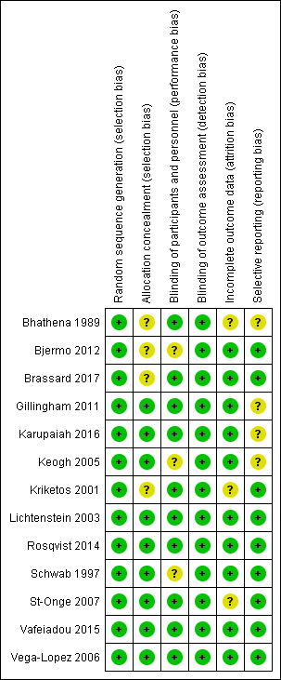

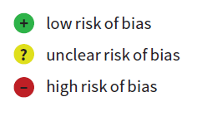

Supplemental Figure 1: Risk of bias assessment

A | 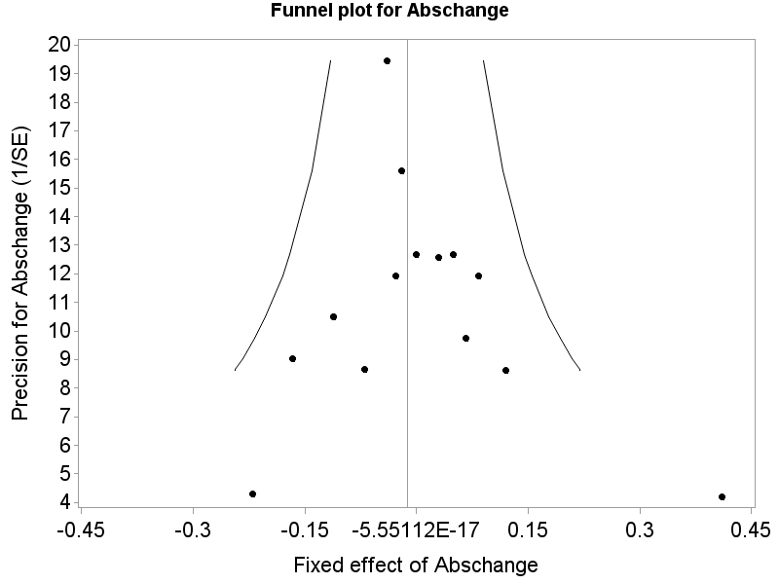 | Glucose  Absolute changes  I²=0%  Egger test: p-value=0.64  Relative changes  I²=5.2%  Egger test: p-value=0.80
B | 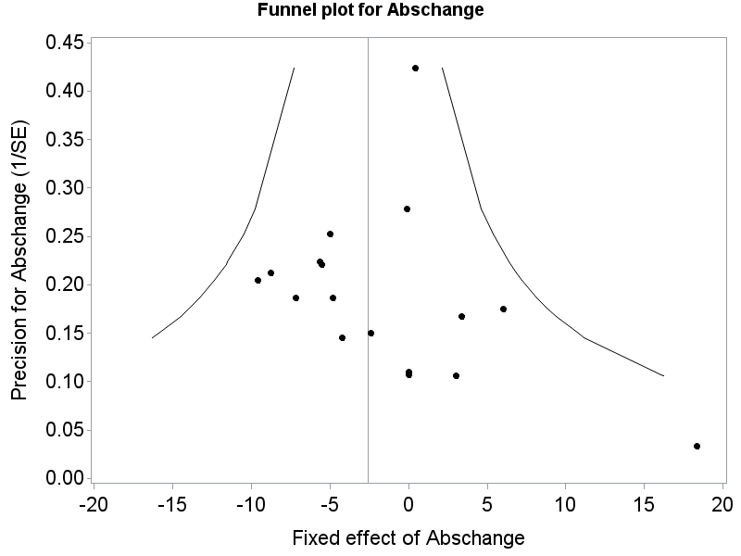 | Insulin  Absolute changes  I²=0%  Egger test: p-value=0.96  Relative changes  I²=0%  Egger test: p-value=0.27
C | 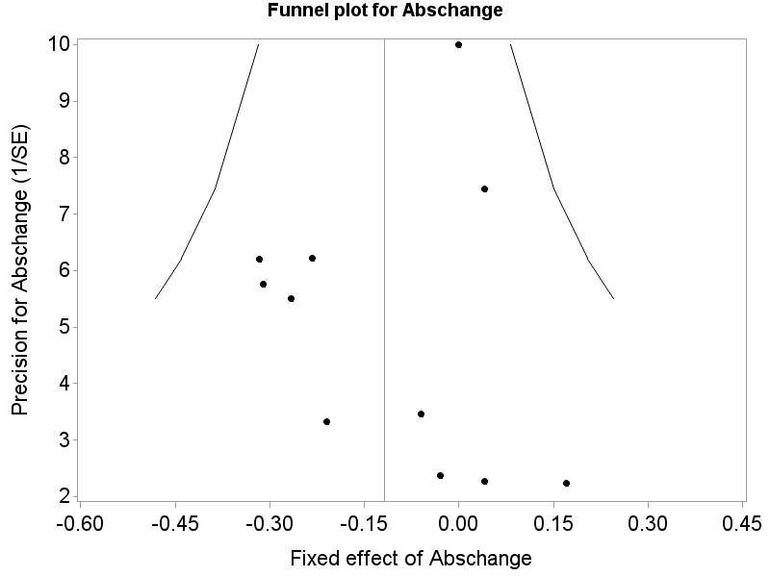 | HOMA-IR  Absolute changes  I²=0%  Egger test: p-value=0.76  Relative changes  I²=0%  Egger test: p-value=0.49
Supplemental Figure 2: Funnel plots for fixed effects of plant-derived PUFA on absolute changes in fasting glucose (mmol/l)(A), insulin (pmol/l)(B) and HOMA-IR (unit)(C).
Abbreviations: HOMA-IR, homeostatic model assessment-insulin resistance; SE, standard error.

A | 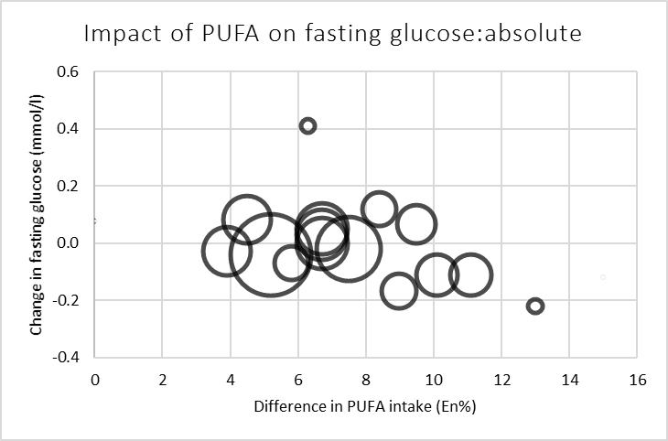 | Fasting glucose:  absolute  change per 1 En% increase in PUFA:  -0.01 mmol/L (95%CI -0.03 to 0.008 mmol/L)
B | 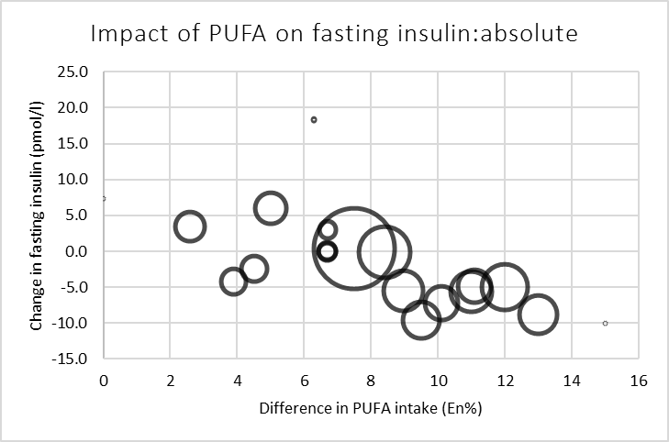 | Fasting insulin: absolute  change per 1 En% increase in PUFA:  -1.15 pmol/L (95%CI -2.05 to -0.26 pmol/L)
C | 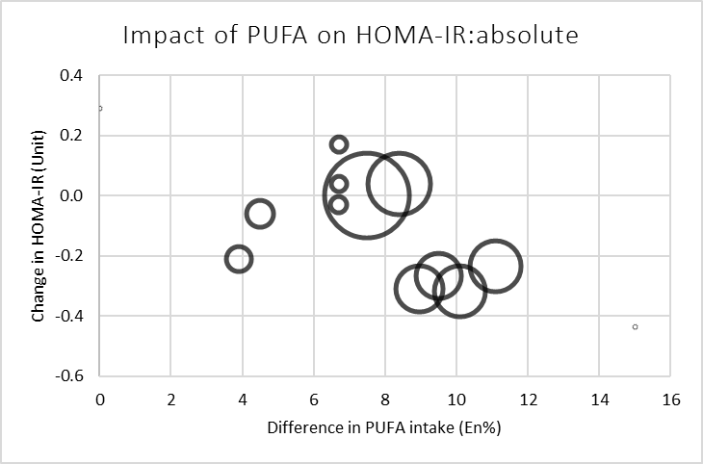 | HOMA-IR:  Absolute  change per 1 En% increase in PUFA:  -0.05 units (95%CI -0.11 to 0.014 units)

Supplemental Figure 3: Dose-response bubble charts# for fixed effects of plant-derived PUFA on absolute changes in fasting glucose (mmol/l)(A), insulin (pmol/l)(B) and HOMA-IR (unit)(C).
Abbreviations: CI, confidence interval; En%, percentage of daily energy; HOMA-IR, homeostatic model assessment-insulin resistance; PUFA, poly-unsaturated fatty acids; SFA, saturated fatty acids.
# Bubble size reflects study weighing factor, calculated by the inverse of the within-study variance (1/SE²).

Supplemental Text 1
Literature search in Pubmed (January 16, 2018)
(exposure)
(((((((((((((((((((((("dietary fat"[Title/Abstract] OR "fatty acids, omega-6"[MeSH Terms]) OR "fatty acids, omega-3"[MeSH Terms]) OR "fatty acids, monounsaturated"[MeSH Terms]) OR monounsaturated[Title/Abstract]) OR mono-unsaturated[Title/Abstract]) OR unsaturated[Title/Abstract]) OR polyunsaturated[Title/Abstract]) OR omega-6[Title/Abstract]) OR omega-3[Title/Abstract]) OR high-fat[Title/Abstract]) OR "low carbohydrate"[Title/Abstract]) OR oleic[Title/Abstract]) OR ((((((((((((((((((((((((((("seed oil*"[Title/Abstract] OR "safflower oil*"[Title/Abstract]) OR "sunflower oil*"[Title/Abstract]) OR "corn oil*"[Title/Abstract]) OR "sesame oil*"[Title/Abstract]) OR "soybean oil*"[Title/Abstract]) OR "soyabean oil*"[Title/Abstract]) OR "rapeseed oil*"[Title/Abstract]) OR "canola oil*"[Title/Abstract]) OR "olive oil*"[Title/Abstract]) OR "nut oil*"[Title/Abstract]) OR "linseed oil*"[Title/Abstract]) OR "grapeseed oil*"[Title/Abstract]) OR "peanut oil*"[Title/Abstract]) OR "avocado oil*"[Title/Abstract]) OR "vegetable oil*"[Title/Abstract]) OR "plant oil*"[Title/Abstract]) OR "plant oils"[MeSH Terms]) OR "almond oil*"[Title/Abstract]) OR "arachis oil*"[Title/Abstract]) OR "mustard oil*"[Title/Abstract]) OR "cottonseed oil*"[Title/Abstract]) OR "flax seed oil*"[Title/Abstract]) OR "alpha-linolenic acid"[MeSH Terms]) OR "alpha linolenic acid*"[Title/Abstract]) OR linoleic[Title/Abstract]) OR "arachidonic acid"[Title/Abstract]) OR (margarine[Title/Abstract] OR margarine'[Title/Abstract] OR margarine's[Title/Abstract] OR margarines[Title/Abstract])))
(outcomes)
AND (((((((((((((((((((((((((("insulin resistance"[MeSH Terms] OR "glucose clamp technique"[MeSH Terms]) OR "glucose tolerance test"[MeSH Terms]) OR "hemoglobin a, glycosylated"[MeSH Terms]) OR ("insulin"[MeSH Terms] OR "insulin"[All Fields])) OR "fasting serum glucose"[Title/Abstract]) OR "fasting plasma glucose"[Title/Abstract]) OR "fasting glucose"[Title/Abstract]) OR glucose) OR cardiometabolic) OR "glucose tolerance"[Title/Abstract]) OR "glucose clamp"[Title/Abstract]) OR glycaemic[Title/Abstract]) OR glycemic[Title/Abstract]) OR "euglycemic"[Title/Abstract]) OR "euglycaemic"[Title/Abstract]) OR "hyperglycemic clamp"[Title/Abstract]) OR "hyperglycaemic clamp"[Title/Abstract]) OR "hyperinsulinemic clamp"[Title/Abstract]) OR "minimal model"[Title/Abstract]) OR "hemoglobin A1c"[Title/Abstract]) OR "glycated hemoglobin"[Title/Abstract]) OR fructosamine[Title/Abstract]) OR "hepatic fat") OR "liver fat") OR "ectopic fat") OR "intravenous glucose tolerance"[Title/Abstract]))
(limits)
AND (((((((randomized[Title/Abstract] OR intervention[Title/Abstract]) OR ward[Title/Abstract]) OR feeding[Title/Abstract]) OR trial[Title/Abstract]) OR "clinical trials as topic"[MeSH Terms]) OR "clinical trial"[Title/Abstract]) OR "comparative study"[Publication Type])) AND ((((((((subjects[Title/Abstract]) OR human*[Title/Abstract]) OR volunteer*[Title/Abstract]) OR participant*[Title/Abstract]) OR men[Title/Abstract]) OR women[Title/Abstract]) OR individuals[Title/Abstract]) OR patients[Title/Abstract]) NOT ((("case-control studies"[MeSH Terms] NOT "cohort studies"[MeSH Terms]) NOT "models, animal"[MeSH Terms]) NOT "in vitro techniques"[MeSH Terms]))))))))

