Supplementary Table 1. DISCOVER inclusion and exclusion criteria.
Inclusion criteria
- Diagnosis of type 2 diabetes
- Aged ≥18 yearsª
- Initiating a second-line therapy (add-on or switching) after a first-line oral treatment with monotherapy, dual therapy, or triple therapy^{b}
- Provision of written informed consent
Exclusion criteria
- Type 1 diabetes
- Pregnancy
- Initiation of dual therapy after having previously received two different lines of monotherapy (e.g. initiation of a combination of a sulphonylurea and a DPP-4 inhibitor after successive metformin monotherapy and sulphonylurea monotherapy)
- Current treatment with chemotherapy or oral or intravenous steroids
- Undergoing dialysis or has had a renal transplant
- First-line treatment was insulin or another injectable agent^{c}
- First-line treatment was herbal remedies/natural medicines alone
- Participation in an interventional trial
- Condition or circumstance which, in the opinion of the investigator, could significantly compromise the 3-year follow-up (e.g. life-threatening comorbidities, tourist, non-native speaker or does not understand the local language when interpreter services are not reliably available, psychiatric disturbances, dementia, alcohol or drug abuse)
- Not willing to sign the informed consent form
ª≥20 years for Japan.
^{b}For Japan, only patients using an oral monotherapy as first-line treatment were included.
^{c}Patients who received short-term initial treatment with insulin followed by oral therapy were eligible if the treatment with insulin lasted no more than 2 weeks and occurred at least 6 months before initiation of second-line therapy. In such cases, insulin was considered not as a first-line treatment, but as an acute treatment to lower glycemic levels quickly before starting regular treatment.
DDP-4, dipeptidyl peptidase-4.
Supplementary Table 2. Main inclusion and exclusion criteria for CANVAS, DECLARE-TIMI 58, EMPA-REG OUTCOME, and VERTIS-CV.
Criterion | CANVAS | DECLARE-TIMI 58 | EMPA-REG OUTCOME |  | VERTIS-CV
All patients
HbA_{1c}, % | 7.0 to 10.5 | 6.5 to 12.0 | 7.0 to 10.0 |  | 7.0 to 10.5
CKD history | Patients with eGFR <30 mL/min/1.73 m² or a diagnosis code for CKD were excluded | Patients with eGFR <60 mL/min/1.73 m² or a diagnosis code for CKD were excluded | Patients with eGFR <30 mL/min/1.73 m² or a diagnosis code for CKD were excluded |  | No exclusion criterion
BMI, kg/m² | No criterion |  |  | ≥18.0
Patients with CV risk factors but no established CVD
Age, years | ≥50 | >55 (men), >60 (women) | NAª |  | NAª
CV risk factors | At least two of the following risk factors:  - hypertension (SBP >140 mmHg) and/or on antihypertensive therapy  - dyslipidemia (LDL-C ≥154 mg/dL and/or HDL-C ≤39 mg/dL) and/or on lipid-lowering drug  - duration of diabetes ≥10 years  - tobacco use (≥0.5 packet per day) | At least one of the following risk factors:  - dyslipidemia (LDL-C >130 mg/dL within the last 12 months and/or on lipid-lowering therapy)  - hypertension (BP >140/90 mmHg) and/or on antihypertensive therapy  - tobacco use (≥5 cigarettes per day for at least 1 year) | NAª |  | NAª
Patients with established CVD
Age, years | ≥30 | ≥40 | ≥18 |  | ≥40
CV history | History of at least one of the following:  - ACS (treated in hospital)  - angina  - CABG  - CHD  - HF  - ischemic stroke  - MI  - PCI | History of at least one of the following:  - ankle/brachial index <0.90 documented within last 12 months  - CABG  - carotid stenting or endarterectomy  - current symptoms of intermittent claudication  - ischemic stroke  - lower extremity amputation because of peripheral arterial obstructive disease  - MI  - objective stenosis (>50%) in at least two coronary arteries  - PCI  - peripheral arterial stenting or surgical revascularization | History of at least one of the following:  - angina  - CABG  - CAD  - ischemic or hemorrhagic stroke  - MI  - objective stenosis (>50%) in at least two coronary arteries  - occlusive PAD (limb angioplasty stenting or bypass surgery, limb or foot amputation due to circulatory insufficiency, evidence of significant peripheral artery stenosis)  - PCI |  | History of at least one of the following:  - angina  - CABG  - CAD  - ischemic stroke  - MI  - PAD  - PCI
ªNo patients without established CVD in EMPA-REG OUTCOME and VERTIS-CV.
ACS, acute coronary syndrome; BMI, body mass index; BP, blood pressure; CABG, coronary artery bypass graft; CAD, coronary artery disease; CHD, coronary heart disease; CKD, chronic kidney disease; CV, cardiovascular; CVD; cardiovascular disease; eGFR, estimated glomerular filtration rate; HbA_{1c}, glycated hemoglobin; HDL-C, high-density lipoprotein cholesterol; HF, heart failure; LDL-C, low-density lipoprotein cholesterol; MI, myocardial infarction; NA, not applicable; PAD, peripheral artery disease; PCI, percutaneous coronary intervention; SBP, systolic blood pressure.
Supplementary Table 3. Baseline characteristics of DISCOVER patients included in the analysis, and patients participating in DECLARE-TIMI 58, CANVAS, EMPA-REG OUTCOME, and VERTIS-CV trials.
 | DISCOVER  N=11 385 | CANVAS  N=10 142 | DECLARE-TIMI 58  N=17 160 | EMPA-REG OUTCOME  N=7034 | VERTIS-CV  N=8237
Men, % | 56.1 | 64.2 | 62.6 | 71.5 | 70.0
Region, %
North America | 1.9 | 24.0 | 31.9 | 41.0ª | Not reported
Latin America | 10.2 | 10.1 | 10.9 | 15.4 | Not reported
Asia-Pacific | 45.7 | 30.3 | 12.7 | 19.1 | Not reported
Europe | 19.1 | 35.6 | 44.5 | 20.0 | Not reported
Middle East and Africa | 23.0 | 0.0 | 0.0 | 4.4 | Not reported
Age, mean (SD), years | 57.4 (12.1) | 63.3 (8.3) | 63.8 (6.8) | 63.1 (8.6) | 64.4 (8.1)
HbA_{1c}, mean (SD) | 8.3 (1.7) | 8.2 (0.9) | 8.3 (1.2) | 8.1 (0.8) | 8.3 (0.9)
BMI, mean (SD), kg/m² | 29.1 (5.9) | 32.0 (5.9) | 32.1 (6.0) | 30.6 (5.3) | 32.0 (5.4)
Time since T2D diagnosis, mean (SD), years | 5.6 (5.2) | 13.5 (7.8) | 11.8 (7.8) | NA | 12.9 (8.3)
Current smoker, % | 15.8 | 17.8 | 14.5 | 13.2 | Not reported
History of CVD, % | 14.4^{b} | 64.8 | 40.6 | 99.2^{c} | 99.0
Use of antihypertensive drugs, % | 50.5 | 79.8 | 89.4 | 94.4 | Not reported
ªAlso includes patients from Australia and New Zealand.
^{b}Proportion of patients for whom macrovascular complications (coronary heart disease, cerebrovascular disease, peripheral artery disease, heart failure, or implantable cardioverter defibrillator use) were marked as present by the investigator.
^{c}Proportion of patients with a history of myocardial infarction, single-vessel coronary artery disease, multi-vessel coronary artery disease, coronary artery bypass graft, stroke, or peripheral occlusive arterial disease.
BMI, body mass index; CVD, cardiovascular disease; HbA_{1c}, glycated hemoglobin; SD standard deviation; T2D, type 2 diabetes.
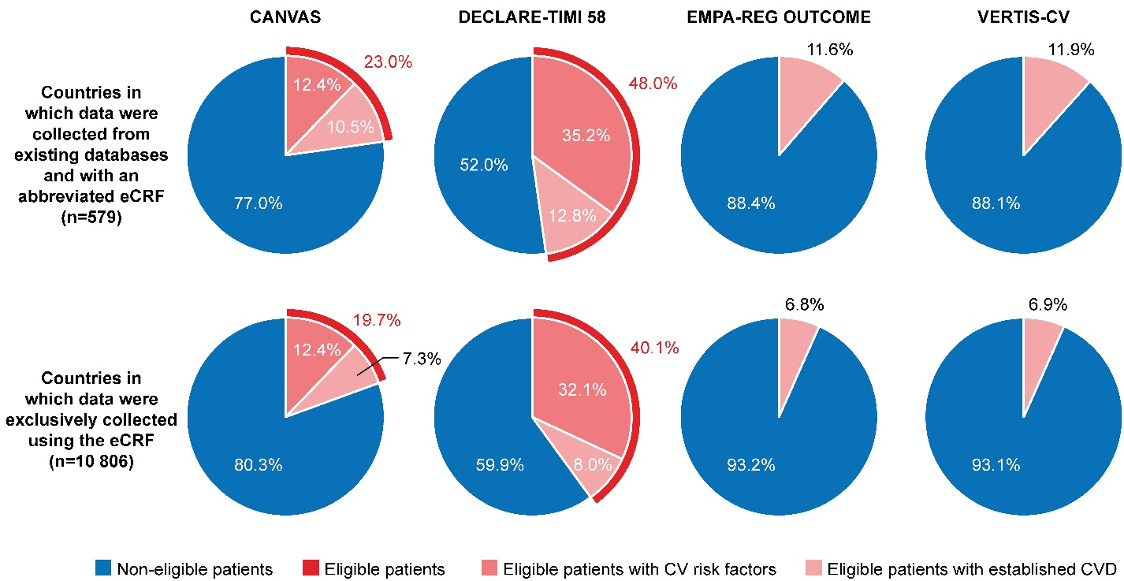
Supplementary Figure 1. Estimated proportions of DISCOVER patients who would have been eligible for CANVAS, DECLARE-TIMI 58, EMPA-REG OUTCOME, and VERTIS-CV in countries in which some data were extracted from existing databases, compared with all other countries.
CV, cardiovascular; CVD, cardiovascular disease; eCRF, electronic case report form.

