Urinary adiponectin as a new diagnostic index for chronic kidney disease due to diabetic nephropathy

Supplemental Data

- SUBJECT INFORMATION

Supplemental Table 1 Information for DM patients whose urinary adiponectin levels were measured by using our ultrasensitive ELISA

No | BMI | HbA1c  (%) | blood sugar  (mg/dL) | eGFR  (mL/min/1.73 m²) | ACR (mg/gCr) | LDL-C (mg/dL) | TG (mg/dL) | HDL-C (mg/dL) | DM type | antidiabetic drugs used [1] | antihypertensive drugs used
1 | 26.2 | 7.3 | 76 | 72.1 | 8.3 | 83 | 105 | 81 | type 2 | sulfonylurea (SU), metformin, dipeptidyl peptidase-4 inhibitor (DPP-4i) | no prescription
2 | 24.5 | 6.8 | 149 | 55.8 | 62.2 | 78 | 83 | 83 | steroid-induced diabetes | insulin | angiotensin II receptor blocker (ARB), others
3 | 30.0 | 5.5 | 87 | 39.2 | 4.5 | 145 | 178 | 69 | type 2 | no prescription | ARB, others
4 | 19.5 | 6.5 | 180 | 22.1 | 2.1 | 87 | 148 | 35 | type 2 | insulin | ARB, others
5 | - | 7.5 | 185 | 109.8 | 3.3 | 120 | 54 | 65 | type 2 | SU, DPP-4i | no prescription
6 | 22.7 | 6.3 | 126 | 68.5 | 0.4 | 70 | 159 | 29 | type 2 | DPP-4i | ARB, others
7 | 31.4 | 6.6 | 122 | 56 | 4.4 | 159 | 69 | 51 | type 2 | SU, DPP-4i | no prescription
8 | 29.6 | 6.2 | 190 | 87.5 | 32 | 61 | 189 | 27 | type 2 | SU, α-glucosidase inhibitor (α-GI), DPP-4i | no prescription
9 | 31.8 | 8.1 | 179 | 86.7 | 3397 | 124 | 92 | 50 | type 2 | SU, metformin, α-GI, DPP-4i | no prescription
10 | 24.0 | 7.4 | 213 | 72 | 16 | 181 | 214 | 45 | type 2 | thiazolidinedione (TZD), α-GI, glinide | no prescription
11 | 25.4 | 7.3 | 242 | 86.9 | 10 | 98 | 44 | 80 | type 2 | sodium/glucose cotransporter-2 inhibitor (SGLT2i), SU, metformin, DPP-4i | others
12 | 24.1 | 8.5 | 249 | 46.6 | 467.5 | 116 | 117 | 36 | type 2 | TZD, SU, α-GI, DPP-4i | ARB, others
13 | 16.1 | 6.4 | 192 | 50.2 | 307.8 | 73 | 54 | 55 | type 2 | α-GI, glinide, DPP-4i, insulin | angiotensin converting enzyme (ACE) inhibitor, others
14 | 31.2 | 7.7 | 101 | 74.7 | 370.4 | 110 | 59 | 65 | type 2 | TZD, insulin | ARB
15 | 26.4 | 6.9 | 162 | 81.3 | 33.7 | 67 | 157 | 45 | type 2 | glinide, DPP-4i | others
16 | 16.7 | 6.2 | 138 | 60.8 | 24.6 | 77 | 85 | 38 | type 2 | DPP-4i | others
17 | 24.6 | 6.0 | 121 | 58.1 | 75.7 | 79 | 166 | 52 | type 2 | glinide | others
18 | 28.6 | 6.2 | 131 | 62.6 | 23.5 | 92 | 136 | 71 | type 2 | metformin, α-GI, DPP-4i | no prescription
19 | 41.6 | 7.1 | 86 | 47.8 | 6.5 | 119 | 57 | 52 | type 2 | DPP-4i, insulin | ARB, others
20 | 22.1 | 7.3 | 123 | 56.9 | 170.2 | 139 | 118 | 58 | type 2 | SGLT2i, α-GI, glinide | ARB, others
21 | 22.6 | 6.2 | 109 | 52.9 | 7 | - | 94 | - | type 2 | DPP-4i, insulin | no prescription
22 | 29.1 | 6.9 | 142 | 91.2 | 5.5 | 116 | 78 | 50 | type 2 | SGLT2i, SU, DPP-4i, insulin | no prescription
23 | 20.5 | 5.5 | 83 | 21.5 | 174.6 | 45 | 131 | 41 | type 1 | insulin | no prescription
24 | - | 8.8 | 274 | 56 | 1469 | 150 | 96 | 37 | type 2 | TZD, α-GI, DPP-4i, insulin | no prescription
25 | 20.8 | 7.4 | 122 | 65.9 | 12.8 | 87 | 55 | 54 | steroid-induced diabetes | DPP-4i | no prescription
26 | 21.0 | 7.8 | 153 | 47.1 | 594.3 | 72 | 354 | 38 | type 2 | SU, glucagon like peptide-1 receptor agonist (GLP-1RA) | ACE inhibitor, others
27 | 25.3 | 7.6 | 204 | 88.1 | 22.3 | 111 | 152 | 46 | type 2 | SU, metformin, DPP-4i | no prescription
28 | 20.0 | 6.3 | 106 | 122.4 | 11.8 | 99 | 163 | 55 | type 2 | no prescription | no prescription
29 | 29.8 | 8.2 | 127 | 76.1 | 5.8 | 134 | 120 | 45 | type 2 | SGLT2i, insulin | ARB, others
30 | 19.1 | 9.5 | 227 | 98.6 | 13.7 | 149 | 227 | 36 | mitochondrial diabetes | DPP-4i, insulin | no prescription
31 | - | 6.6 | 101 | 55.6 | 15.9 | 118 | 232 | 44 | type 2 | no prescription | no prescription
32 | - | 6.4 | 199 | 54.7 | 20.7 | 113 | 126 | 52 | type 2 | glinide, DPP-4i, insulin | no prescription
33 | 28.8 | 5.6 | 153 | 24.5 | 9673 | 245 | 459 | 66 | type 2 | DPP-4i | ARB, others
34 | 23.5 | 6.0 | 160 | 27.5 | 62.5 | - | 78 | - | type 2 | α-GI, insulin | ARB
35 | 19.8 | 6.6 | 117 | 14.3 | 9.3 | 125 | 45 | 116 | type 2 | α-GI | no prescription
36 | 26.2 | 6.6 | 114 | 21.2 | 20 | 125 | 206 | 52 | type 2 | α-GI, DPP-4i | ARB, others
37 | 23.1 | 6.4 | 154 | 13.3 | 2.6 | 68 | 116 | 35 | type 2 | α-GI, DPP-4i, insulin | others
38 | 32.5 | 9.6 | - | 51.3 | 1598 | 27 | 70 | 29 | type 2 | insulin | ARB, others
39 | 33.6 | 6.2 | 106 | 19.2 | 23.7 | 97 | 87 | 44 | type 2 | insulin | ACE inhibitor, others
40 | 28.6 | 6.2 | 129 | 17.2 | 6.9 | 96 | 254 | 43 | type 2 | TZD | no prescription
41 | 28.1 | 8.0 | 149 | 11.3 | 6.5 | 80 | 457 | 35 | type 2 | SU, α-GI, glinide, DPP-4i, insulin | no prescription
42 | 28.0 | 6.8 | 114 | 45.5 | 54.6 | 65 | 378 | 32 | type 2 | TZD, glinide, insulin | no prescription
43 | 34.1 | 6.7 | 269 | 62 | 336.3 | 106 | 68 | 42 | type 2 | SU, metformin, DPP-4i | ARB, others
44 | - | 5.9 | 98 | 76.7 | 7.8 | - | - | - | type 2 | no prescription | no prescription
45 | 27.8 | 9.8 | 54 | 46 | 792.2 | 99 | 48 | 47 | type 1 | insulin | ARB
46 | 22.2 | 6.6 | 100 | 50.5 | 13 | 119 | 81 | 62 | type 2 | DPP-4i | ARB, others
47 | 20.9 | 7.4 | 106 | 77.8 | 5.2 | 116 | 213 | 65 | type 2 | insulin | no prescription
48 | 26.2 | 5.5 | 89 | 31.8 | 25.8 | 128 | 137 | 30 | type 2 | DPP-4i | others
49 | 31.8 | 6.1 | 175 | 73.1 | 11.5 | 49 | 126 | 53 | type 2 | SGLT2i, DPP-4i | no prescription
50 | 28.7 | 7.0 | 184 | 64.1 | 394.8 | 97 | 86 | 56 | type 2 | SU | ARB, others
51 | 21.0 | 6.5 | 98 | 32.1 | 282.1 | 112 | 163 | 41 | type 2 | insulin | others
52 | - | 9.3 | 352 | 50.3 | 454.3 | 115 | 109 | 61 | type 2 | TZD, α-GI, glinide, DPP-4i, insulin | ARB, others
53 | 21.5 | 7.8 | 119 | 25.3 | 187.2 | 119 | 205 | 48 | type 2 | insulin | others
54 | 21.1 | 6.8 | 224 | 59.1 | 1775.1 | 95 | 54 | 55 | type 2 | glinide | ARB, others
55 | 26.0 | 7.4 | 198 | 80.3 | 1137.8 | 110 | 94 | 50 | type 2 | SU, DPP-4i | ARB, others
56 | 23.6 | 8.4 | 264 | 43.7 | 1337.2 | 117 | 87 | 52 | type 2 | DPP-4i, insulin | ARB, others
57 | 24.5 | 6.4 | 134 | 68.3 | 290.5 | 115 | 82 | 43 | type 2 | SU, α-GI, DPP-4i | ARB, others
58 | 25.3 | 6.2 | 145 | 20.3 | 104.1 | 136 | 196 | 39 | type 2 | DPP-4i, insulin | no prescription
59 | 39.4 | 8.2 | 238 | 101.7 | 19.1 | 90 | 270 | 46 | type 2 | TZD, SU, DPP-4i | ARB, others

The names of antidiabetic drugs followed a style of Davies et al., 2018 [1].
Supplemental Table 2 Information for normal subjects whose urinary adiponectin levels were measured by using our ultrasensitive ELISA

No | BMI | HbA1c  (%) | Height  (m) | Weight  (kg)
1 | 21 | 5.6 | 1.66 | 58
2 | 21 | 5.6 | 1.695 | 60
3 | 18 | 5.4 | 1.66 | 49
4 | 20 | 5.0 | 1.64 | 53
5 | 21 | 5.7 | 1.56 | 52
6 | 21 | 5.2 | 1.54 | 49
7 | 23 | 5.3 | 1.65 | 62
8 | 19 | 5.2 | 1.68 | 53
9 | 22 | 5.5 | 1.55 | 53
10 | 19 | 4.8 | 1.62 | 50
11 | 21 | 5.2 | 1.61 | 54
12 | 21 | 5.4 | 1.56 | 51
13 | 17 | 5.3 | 1.66 | 48
14 | 19 | 5.3 | 1.8 | 60
15 | 22 | 5.2 | 1.68 | 62
16 | 20 | 5.2 | 1.66 | 56
17 | 23 | 5.2 | 1.8 | 73
18 | 21 | 5.6 | 1.61 | 54
19 | 20.7 | 5.1 | 1.63 | 55
20 | 19.9 | 5.1 | 1.52 | 46
21 | 23.4 | 5 | 1.60 | 60
22 | 25.8 | 5.3 | 1.74 | 78
23 | 18.3 | 5.4 | 1.70 | 53
24 | 21.7 | 4.8 | 1.73 | 65

- SPIKE-AND-RECOVERY TEST

The spike-and-recovery tests for urine and serum are the same as described previously [2]. Briefly, we used urine and serum collected from type 2 DM patients (No. 18 for urine sample and No. 1 for serum sample, see Supplemental Table 1) and the adiponectin antigen at a final concentration of 10 pg/mL for urine and 10 pg/mL for serum. The concentrations of the chemicals used were the same as those in our previous study [2]. We then prepared four solutions containing the following:
(1) 100 μL TBS including 0.1% BSA.
(2) For a dilution ratio of 100, 99 μL TBS including 0.1% BSA and 1 μL urine.
(3) 20 μL of recombinant human adiponectin antigen at a concentration of 50 pg/mL in TBS including 0.1% BSA and 80 μL TBS including 0.1% BSA.
(4) 20 μL recombinant human adiponectin antigen at a concentration of 50 pg/mL in TBS including 0.1% BSA, and 1 μL urine and 79 μL TBS including 0.1% BSA.
The spike-and-recovery ratio was calculated as [{the absorbance of (4) ‒ that of (1)} ‒ {the absorbance of (2) ‒ that of (1)}]/[the absorbance of (3) ‒ that of (1)].

We used the urine samples at a 1:100 dilution and a 1:200 dilution, and the serum samples at a 1:200,000 dilution, a 1:500,000 dilution, and a 1:1,000,000 dilution. The spike-and-recovery ratios were 93% for the 1:100 dilution and 91% for the 1:200 dilution of urine, and 98% for the 1:200,000 dilution, 90% for the 1:500,000 dilution, and 116% for the 1:1,000,000 dilution of serum. We therefore measured the urinary adiponectin level at a 1:100 dilution and the serum adiponectin level at a 1:200,000 dilution of the samples.

- Changes in urinary adiponectin levels over time

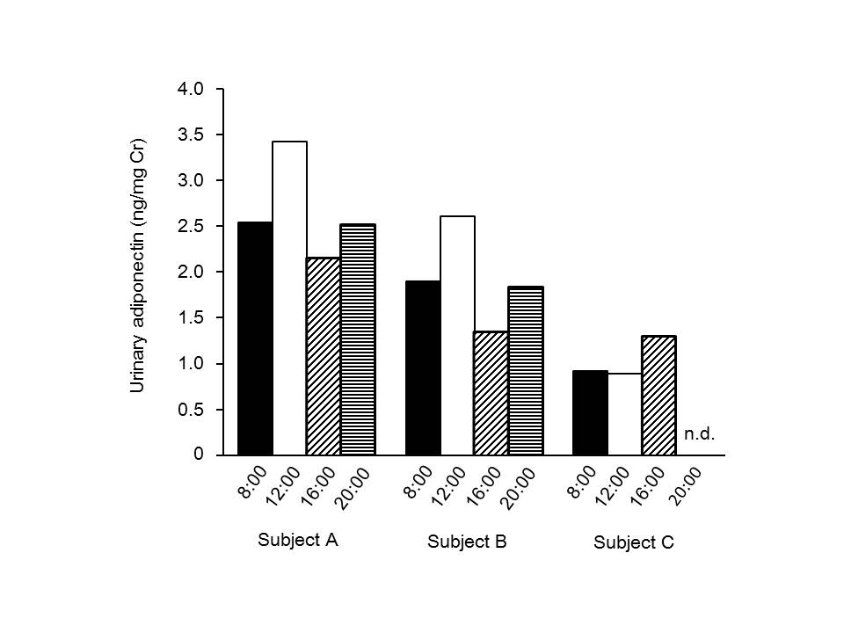
Supplemental Figure 1. Changes in urinary adiponectin levels over time. Urine was collected from three normal subjects every 4 hours at 8 am, 12 pm, 4 pm, and 8 pm) over 1 day. No significant differences were detected in the urinary adiponectin levels in each patient in 1 day (two-way ANOVA and post hoc Tukey test, P > 0.05), even though Subject A and Subject C had significantly different levels (P < 0.05). Black bars: samples collected at 8:00; white bars: samples collected at 12:00 (noon); slash-hatched bars: samples collected at 16:00; horizontal-hatched bars: samples collected at 20:00. n.d. indicates not detected. Therefore, urinary adiponectin levels samples did not show a dependence on the time of day over a 1-day period.

- FOLLOW-UP STUDY

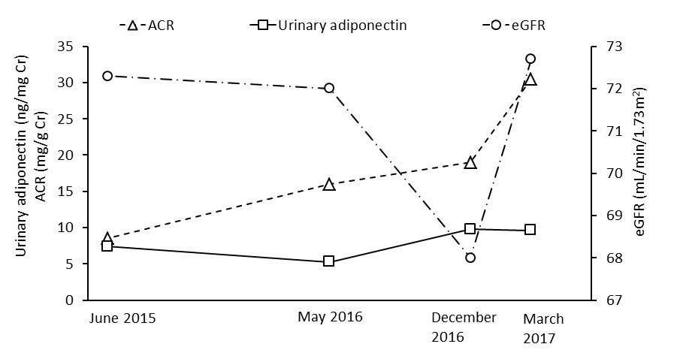

Supplemental Figure 2. Follow-up study of a DM patient (No. 10). CKD progression positively correlated with the urinary adiponectin levels (see Fig. 3A). We examined a follow-up survey of 6 DM patients (Nos. 1, 5, 10, 11, 30, 32 in Supplemental Table 1). In one of these six DM patients (No. 10), the CKD classification advanced from G2A1 to G2A2 due to an increase in the ACR (i.e., urinary albumin level; Table 1). We measured the ACR, eGFR, and urinary adiponectin level in this DM patient four times during the period from April 2015 to April 2017. The changes in the ACR and eGFR between December 2016 and April 2017 were quite large: the eGFR value improved (i.e., higher), whereas the ACR value worsened (i.e., higher). The urinary adiponectin level, however, remained fairly stable. All the DM patients examined in the present study received medical treatment, and therefore it was reasonable that the CKD classification for the patients did not advance so readily. In the case of patient No. 10, the ACR and eGFR values fluctuated, and the urinary adiponectin level was stable. In particular, the physician in charge of this patient (No.10) thought that the decrease in the eGFR recorded in December 2016 occurred due to the patient’s recent participation in a walking event. The eGFR value returned to the previous level in March 2017. Further, as indicated in Fig. 4C, urinary adiponectin levels are much more responsive than ACR levels, indicating that the urinary adiponectin level is reliable. Taken together, we believe that our measured urinary adiponectin level is reasonable and useful as a new index for CKD classification.
References

1. Davies MJ, D'Alessio DA, Fradkin J, Kernan WN, Mathieu C, Mingrone G, Rossing P, Tsapas A, Wexler DJ, Buse JB. Management of hyperglycemia in type 2 diabetes, 2018. A consensus report by the American Diabetes Association (ADA) and the European Association for the Study of Diabetes (EASD). Diabetes Care 2018;41:2669-2701.

2. Morikawa M, Naito R, Mita K, Watabe S, Nakaishi K, Yoshimura T, Miura T, Hashida S, Ito E. Subattomole detection of adiponectin in urine by ultrasensitive ELISA coupled with thio-NAD cycling. Biophys Physicobiol 2015;12:79-86.

